<>cmeprojects
User manual
For staff, team leaders and managers: every screen, step by step
Engaged Care Melbourne · Staff Portal
Version 1.1 · November 2026
Prepared by cmeprojects

Contents

Right-click the list and choose Update field if the page numbers don't show.

About this manual
This manual is for everyone who uses the Engaged Care Staff Portal: support workers, team leaders, managers and staff admins. It explains every screen you'll use day to day. The system admin has a separate manual.

What you see depends on your role
Everyone signs in to the same portal, but each role sees different menus. If something in this manual isn't on your screen, your role doesn't need it.
Role | What you can do
New starter | Your onboarding only: read and confirm documents, complete trainings, upload certificates and answer forms. You get a role once onboarding is done (or earlier, as a conditional role).
Support worker | Your own tasks: ones you're assigned to, helping on or raised. Raise questions and general tasks, use the cars and the Staff app.
Team leader | Everything a support worker can do, plus the tasks of everyone in your team, and registers.
Manager | Every team's tasks, approvals, reports, due dates, staff, teams and roles.
Staff admin | Like HR: invites people, keeps their details and compliance up to date. Role and team changes may need a manager's approval.

Getting started

Your welcome email
- You'll get an email from Engaged Care with the subject You're invited.
- Press Accept your invite. The link works once and expires. If it has expired, ask your staff admin to resend it.
- Choose a password of at least 10 characters. A short sentence is easiest to remember, for example mytea-is-always-cold.
- You're taken to My onboarding.

Signing in
- Open the company website and press Sign in at the top right, or go straight to the portal address.
- Type your email and password and press Sign in.
- If your role needs two-factor login, type the 6-digit code from your authenticator app.
- Forgot your password? Press Forgot password on the sign-in page and follow the email.
- Five wrong passwords lock your account for 15 minutes. Wait, or use Forgot password.
- Signed out by itself? For safety, the portal signs you out after a period of no use. Your work is saved; just sign in again.

Two-factor login
Two-factor login protects your account even if someone learns your password. Managers, staff admins and system admins usually need it.
- Install an authenticator app on your phone, such as Microsoft Authenticator or Google Authenticator.
- When the portal shows a QR code, open the app, add an account and scan it.
- Type the 6-digit code the app shows. From now on, you'll type a new code each time you sign in.
Good to know
Lost your phone? Ask the system admin to reset your two-factor login. You'll set it up again next time you sign in.

My account
Press your name at the top right, then My account, to change your name or your password, and to sign out.
Lost your phone, or signed in on a computer that isn't yours? On My account, press Sign out my other devices. Every other device is signed out within a minute; the one you're using stays signed in.

Finding your way
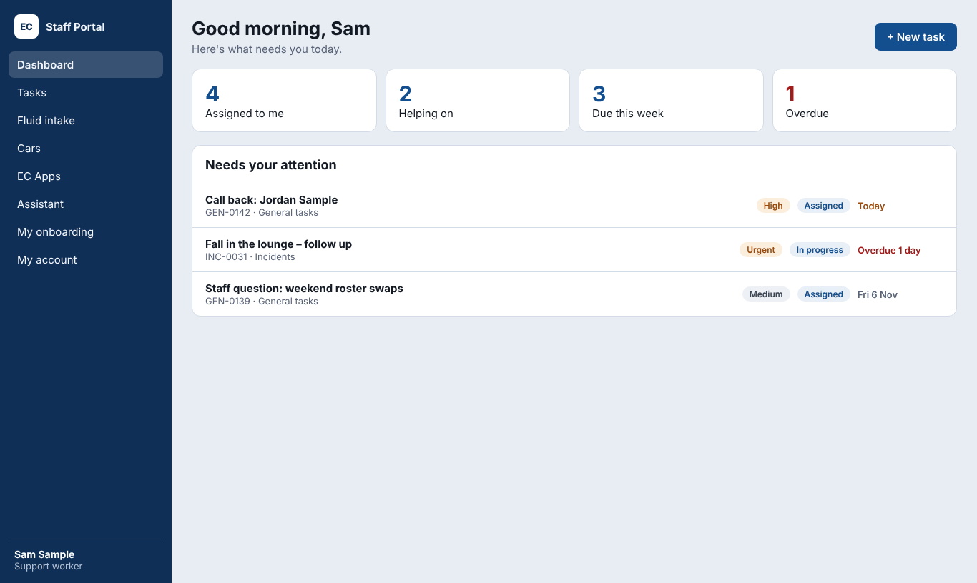
The dashboard: what needs you today.

The menu
Menu | What's in it
Dashboard | Your tasks due today and overdue, things waiting for you, and quick links
Home or Dashboard | Your tasks, your requests and questions, and New task
Registers | Team leaders and up (chosen by the system admin)
Cars | Use a car, manage cars (car managers) and get the Cars app
Forms | Forms you make or manage (if your role can make forms)
People | Staff, teams, roles, clients and compliance (managers and staff admins)
Reports | Task, car, compliance and feature reports (chosen roles)
Tools | Built features (like Fluid intake), Cars and the phone apps

The bell
The bell shows your notifications: a task given to you, an approval, an answer to your question, or a document about to expire. New ones are bold and counted on the bell. Opening one marks it as read, but it stays in the list for 30 days.

On your phone
The portal works in your phone's browser. For cars and daily records, use the Staff app instead (see The Staff app).

The website and Assistant
The company website has an Assistant you can ask questions in plain English. It answers from the company's own documents and from trusted websites such as ndis.gov.au. When you're signed in, it can also use staff-only policies.
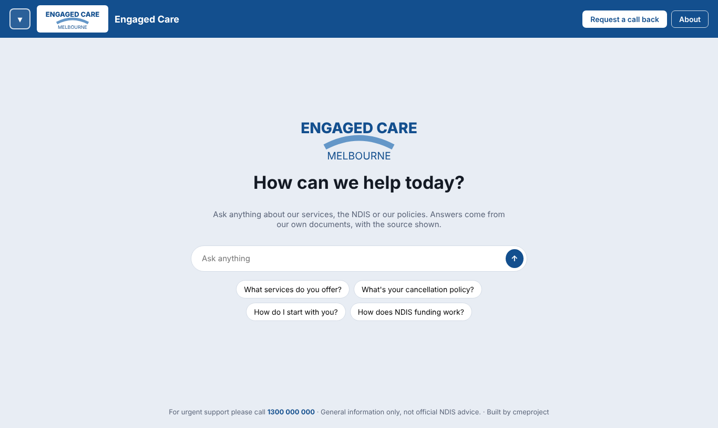
The website: type a question, or press a suggested one.

Asking a question
- Type your question in the box, for example What do I do if a client has a fall?, and press Enter.
- The answer starts with a one-line summary, then the details in bullet points.
- Signed in, the answer ends with Further information can be found in and the document names.
- Ask a follow-up in the same chat. The Assistant remembers what you've asked.
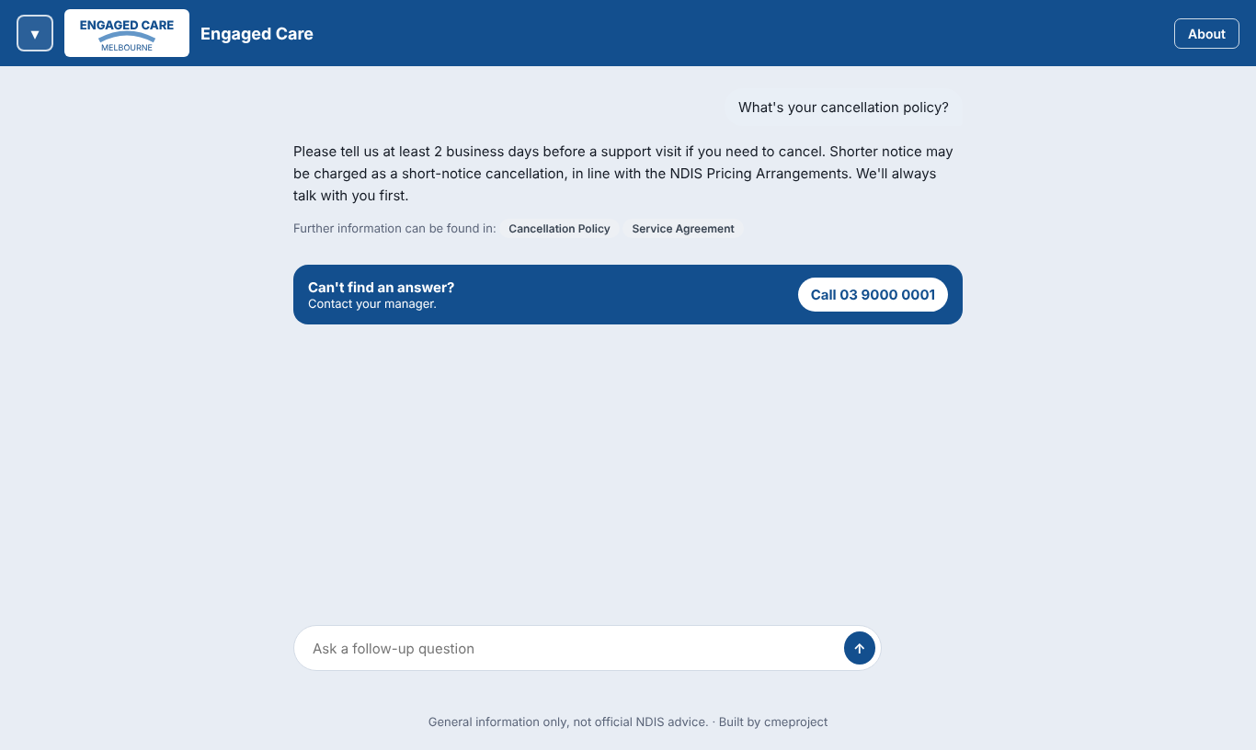
Signed in: staff-only answers, where to read more, and Contact your manager.

When it can't answer
If the answer isn't in the documents, the Assistant says so rather than guessing. Signed-in staff see Can't find an answer? Contact your manager with a Call button that rings the staff contact number.

The options panel and chat history
- Press the logo button at the top left to open the options panel. Hover over it to see Expand to see options.
- Recent chats are kept so you can go back to them. Signed in, they're saved to your account; visitors' chats stay on their own device.
- New chat starts again with a clean page.
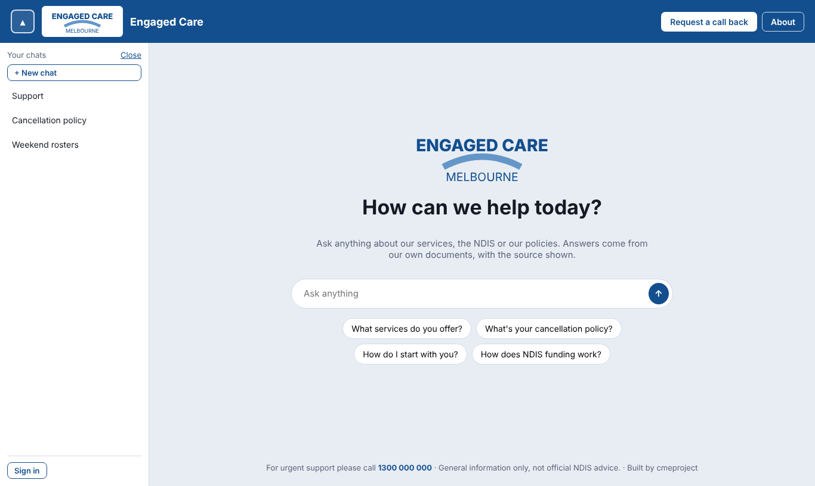
The options panel with recent chats.

Raise a question
Use this when you need a person, not the Assistant, to answer.
- Open the options panel and press Raise a question.
- Type your question and choose who should answer it.
- Press Send question. It becomes a Staff question task, and you follow it in My tasks → My requests.
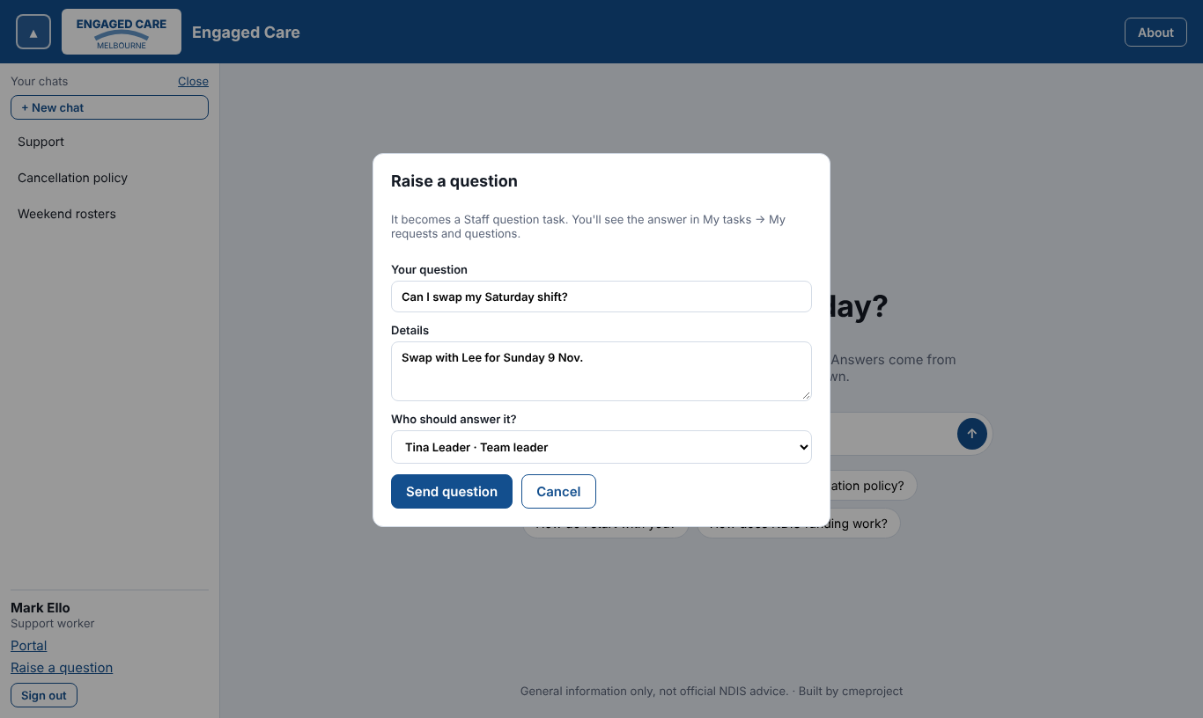
Raise a question.
The footer shows the general support number and that the Assistant gives general information only, not official NDIS advice.

Tasks
A task is anything someone needs to do, with a person responsible, a due date and a history of everything that happened.

Statuses
Status | What it means
Assigned | Given to someone, not started yet
In progress | Being worked on
Escalated | Sent up to a team leader or manager for help
Awaiting approval | Done, waiting for a manager to approve
Completed | Finished
Closed | Finished and signed off; no more changes

Priorities and due dates
Priority | Use it for
Urgent | Safety or a client at risk: today
High | Needs doing in the next day or two
Medium | Normal work: this week
Low | When there's time
Due dates are set from the priority, counting business days only (weekends and public holidays don't count). You get a reminder before a task is due. Overdue tasks are escalated automatically after the number of days your managers have set.

My tasks
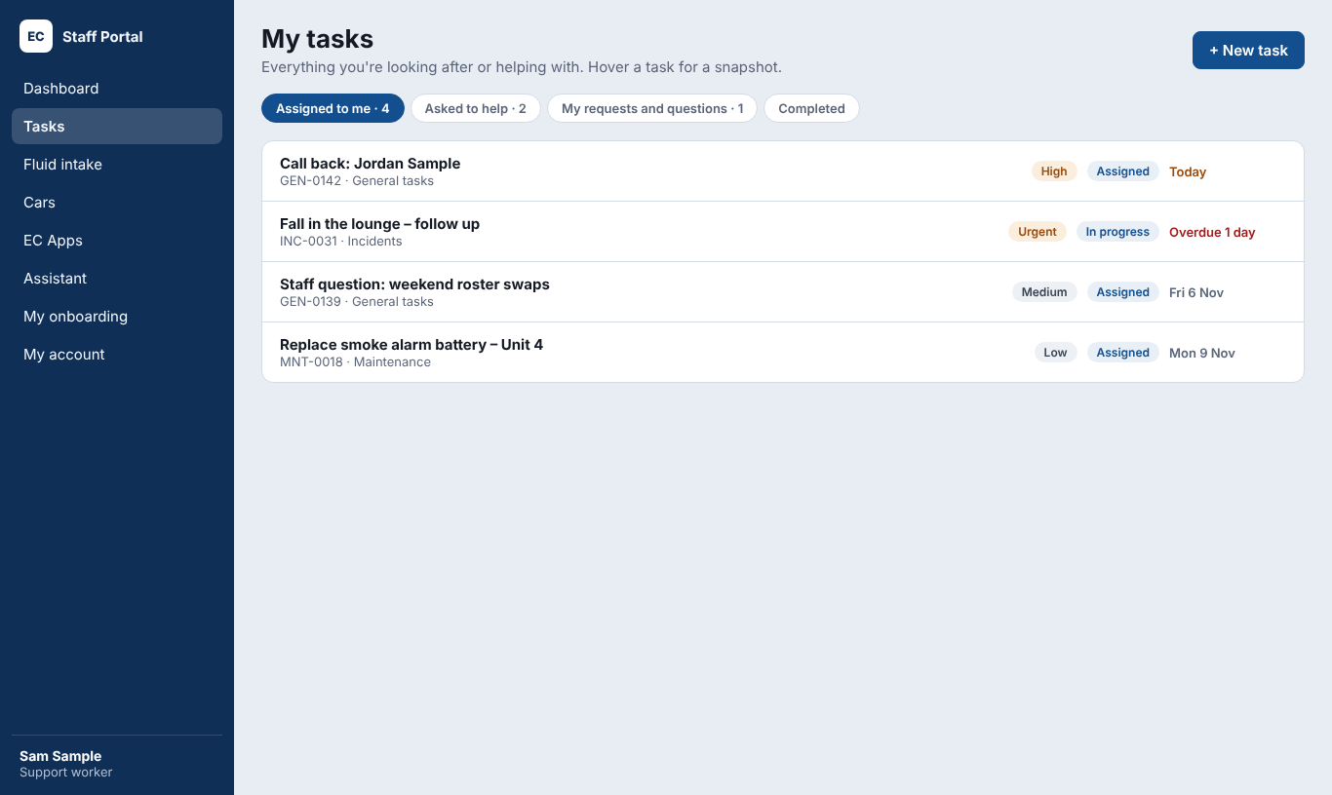
My tasks.
Tab | Shows
Assigned to me | Tasks you're responsible for
Helping | Tasks where you've been added as a helper
My requests | Tasks and questions you raised, and where they're up to
Completed | Your finished tasks
Hover over a task (or press and hold on a phone) to see a quick snapshot without opening it.

Working on a task
Open a task to see its details, history and everything you can do with it.
To… | Do this
Start work | Change the status to In progress
Add an update | Type in Add a comment and press Post. Everyone on the task is told.
Add a photo or document | Attach the file to the task or your comment
Get help | Press Add helper and choose a person. They see it under Helping.
Plan a next step | Add a Follow-up action with what needs doing and when
Send it up | Press Escalate and say why. Your team leader or the managers are told.
Finish | Change the status to Completed. If it needs approval, it goes to Awaiting approval first.
Print it | Press Print for a clean one-page copy
Good to know
Everything you do on a task is recorded with your name and the time. Nothing is deleted, so the history is always complete for audits.

Raising a task or question
- Press New task.
- Choose the type. Support workers can raise a General task or a Question (and tasks in any register its managers have opened to them). A question goes to someone else, so you aren't in the list.
- Add a short title, what's needed and the priority. Choose who it's for, if you can.
- Press Create. You follow it under My requests.
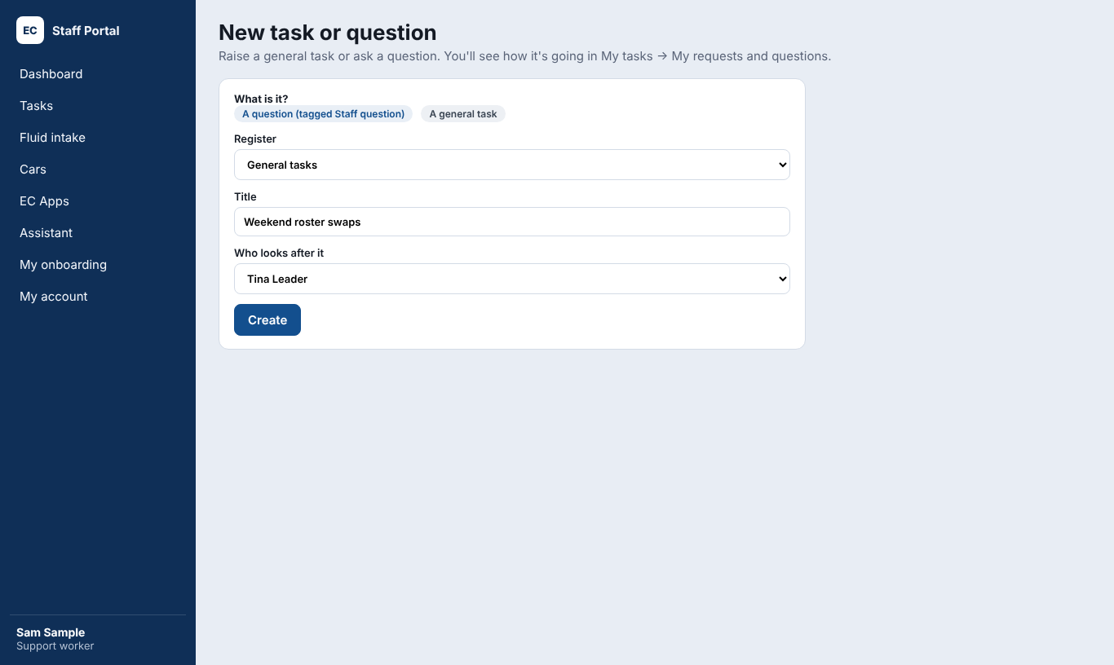
New task or question.

Following up your questions
In My requests, open a question in place to see who has it and the latest updates. Press Follow up to add a note, or Escalate to send it to your team leader or the managers.
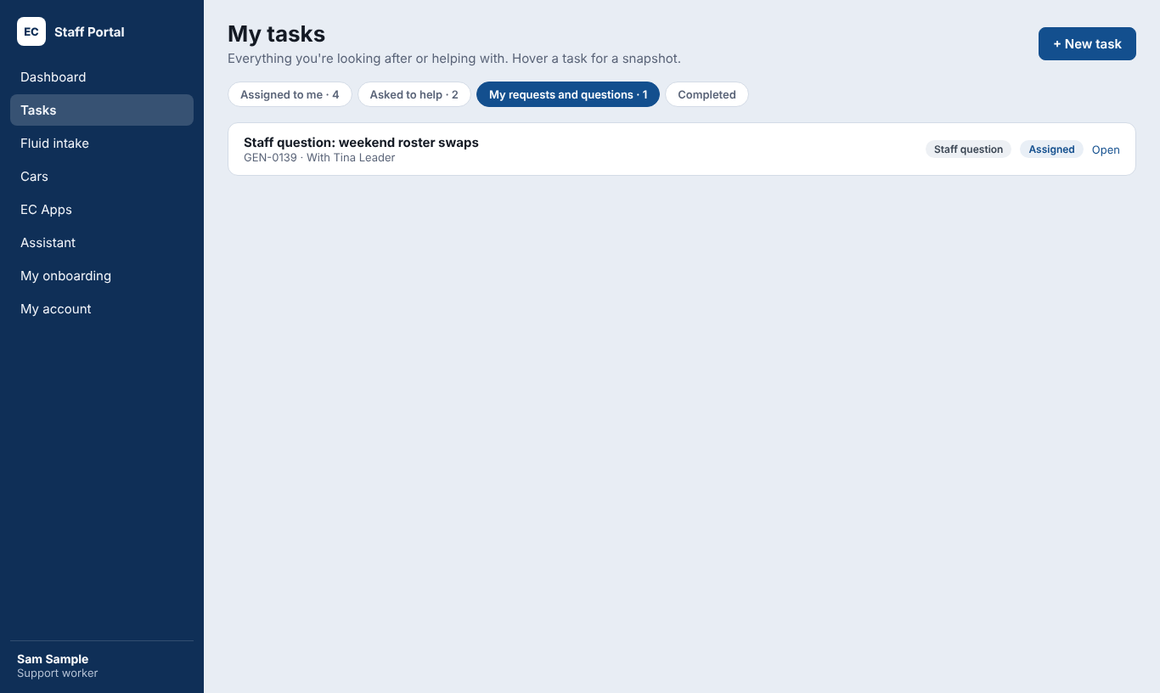
My requests and questions.

Registers
Team leaders and up can see registers: incidents, complaints, risks, maintenance, assets and any others your company uses. Each record is a task with its own fields.
- Open Tasks → Registers and choose a register.
- Press New task, fill in the fields (required ones are marked) and press Create.
- The record follows the same steps as any task: assign, update, approve and close.
- Use the filters to find records, and Export for an Excel copy (if your role can see reports).

My onboarding and compliance
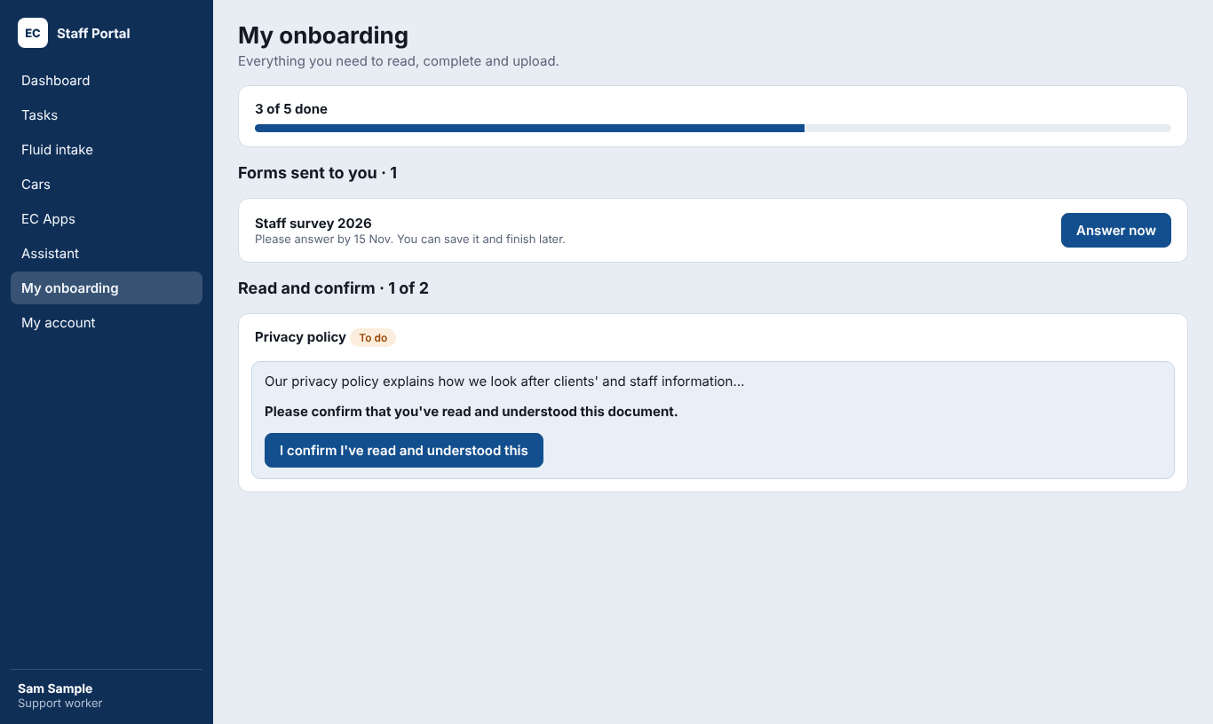
My onboarding.
My onboarding lists everything you need to read, complete and upload for your role and team. Your progress saves as you go.
Item | What to do
Read and confirm | Open the document, read it, then press I confirm I've read and understood this
Training | Complete the training, then upload your certificate or confirm it's done
Upload | Add a photo or PDF (for example a police check or first aid certificate) and its expiry date. A staff admin checks it.
Form | Press Answer now and fill it in
- Sent back? If a staff admin can't accept an upload, you'll see why. Upload a new one.
- Expiring soon? You're reminded before a document expires. Upload the new one in My onboarding.
- Conditional role: you may be given your role before onboarding is finished, with a Finish onboarding task due by a deadline.

Forms
Forms sent to you appear in My onboarding and in the bell. Some forms open from a QR code or a link.
- Open the form and answer the questions. Required ones are marked.
- Press Send when you're done.
- If a form allows it, you can send it anonymously.
- Not sure about a question? Press Ask a question. The person who made it gets a Staff question task.

Cars
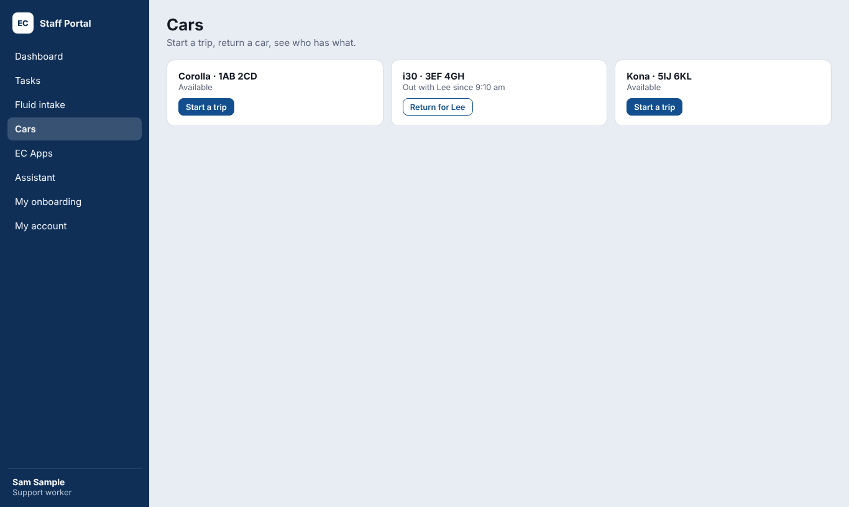
Cars: start a trip or return a car.

Using a car
- Open Cars → Use a car (or the Cars app) and choose a car that's free.
- Choose the purpose and the client, if asked, and enter the odometer reading (with a photo if asked).
- Press Start. You're recorded as the driver, with the date and time.
- When you're back, press Return, enter the odometer reading and any notes (fuel, damage, cleaning).
- Made a mistake? Press Undo within a few minutes of starting or returning.
- Forgot to return a car? You'll get a reminder. A car manager can return it for you.

The Staff app
The Staff app puts the portal's daily tools on your phone's home screen: cars, daily records and forms.

Putting it on your phone
- In the portal, open EC Apps and scan the QR code with your phone's camera.
- iPhone: press Share, then Add to Home Screen. Android: press the menu, then Install app.
- Open the app from your home screen and sign in once.
- Choose a 4-digit PIN.
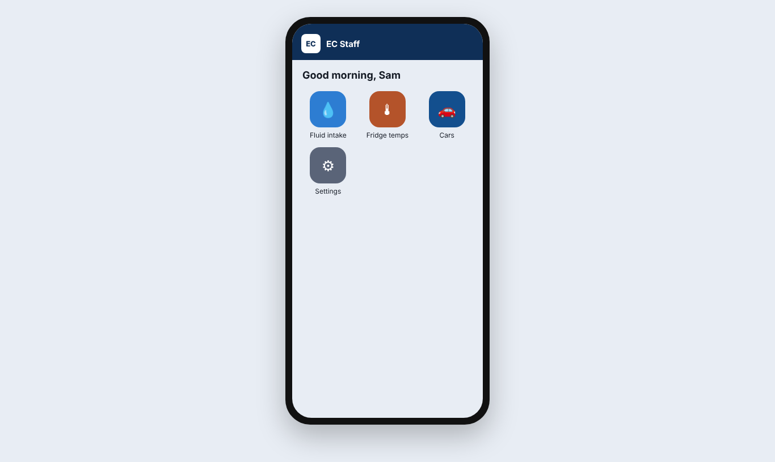
The Staff app on a phone.
Your PIN
The app asks for your PIN each time you open it and after a minute away. Five wrong PINs mean signing in again with your password. A manager can clear your PIN if you forget it.

For team leaders and managers
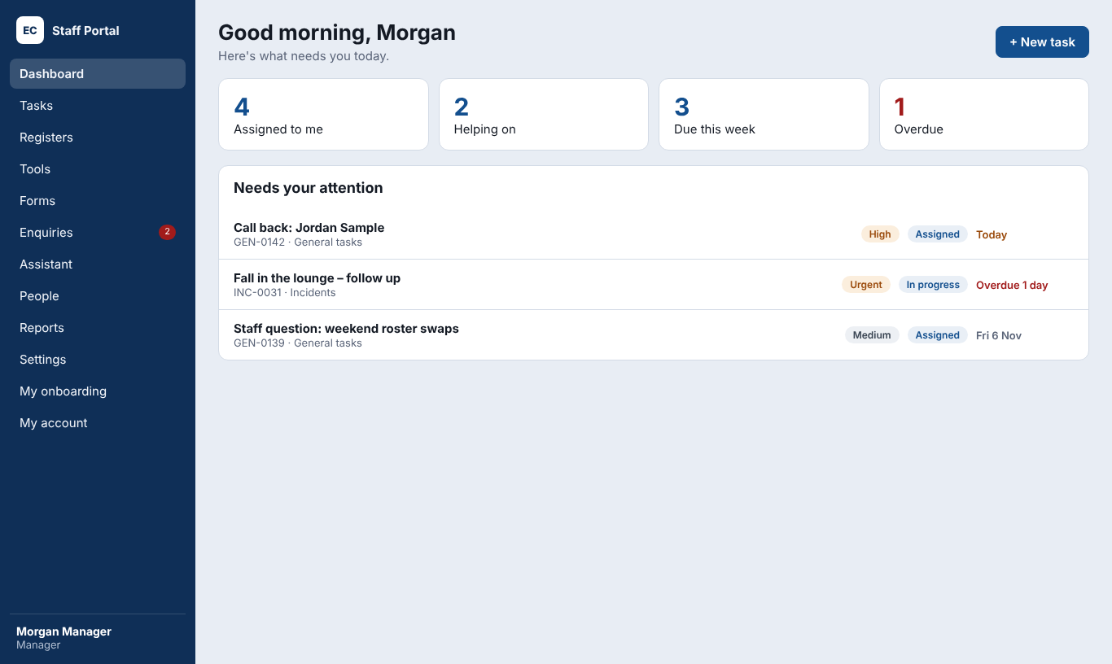
The manager dashboard.
- Dashboard: overdue and escalated tasks across your team (or every team, for managers), approvals waiting and new enquiries.
- Approvals: open a task in Awaiting approval, check the work, then Approve or send it back with a comment.
- Reassign: on a task, press Reassign and choose another person, for example when someone is on leave.
- Scoreboard: tasks completed this week and this year, by person and team.
- Reports: see the system admin manual, or ask your manager which reports your role can see.

Troubleshooting
Problem | What to do
I can't sign in | Check the email address. Use Forgot password. After 5 wrong tries, wait 15 minutes.
My invite link doesn't work | It's been used or has expired. Ask your staff admin to resend the invite.
I keep being signed out | That's the safety timeout after no use. Sign in again; your work is saved.
I can't see a task | You only see tasks you're assigned to, helping on or raised (or your team's, for team leaders).
A training isn't in my onboarding | Items are set per role and team. Ask your staff admin to check yours.
The Assistant can't answer | Press Contact your manager, or use Raise a question.
I forgot my app PIN | Sign in again with your password, or ask a manager to clear your PIN.
I lost my phone | On another device, open My account and press Sign out my other devices. Then tell your manager.

Words we use
Word | Meaning
Task | Something to do, with a person, a due date and a history
Register | A list of one kind of record, like incidents or risks
Helper | Someone added to help on a task
Escalate | Send a task up to a team leader or manager
Business day | Monday to Friday, not a public holiday
Compliance item | Something you must read, complete or upload for your role
Conditional role | A role given before onboarding is finished, with a deadline

